# AIRLINE RESERVATION SYSTEM

**A MINI-PROJECT BY:**

**NITHISH KUMAR K 230701218**

**PRADEEP SINGH 230701229**

***in partial fulfillment of the award of the degree***

***OF***

## *BACHELOR OF ENGINEERING*

**IN**

## COMPUTER SCIENCE AND ENGINEERING



**RAJALAKSHMI ENGINEERING COLLEGE, CHENNAI**

**An Autonomous Institute**

**CHENNAI**

**NOVEMBER 2023**

# BONAFIDE CERTIFICATE

Certified that this project **“AIRLINE RESERVATION MANAGEMENT SYSTEM”** is the bonafide work of **“NITHISH KUMAR K, PRADEEP SINGH”** who carried out the project work under my supervision.

Submitted for the practical examination held on ____________________

SIGNATURE

Ms.ASWANA LAL

Asst.Professor

Computer Science and Engineering,

Rajalakshmi Engineering College

(Autonomous),

Thandalam,Chennai-602105

**INTERNAL EXAMINER EXTERNAL EXAMINER**

# ABSTRACT

Airline Management System is the administration of airports and airlines. It includes the activities of setting the strategy of airports to gather and provide information on airline commercial and operational priorities. It covers a broad overview of the airline management. It is also studied as a branch of study that teaches management of airport and airlines. This provides a broad overview of the airline industry and creates awareness of the underlying marketing, financial, operational, and other factors influencing airline management. This study provides information on airline commercial and operational priorities, along with teaching the key characteristics of aircraft selection and the impact of airport decision making. It provides some amount of automation in airlines management and helps airline system in making their business more efficient. An added attraction for their potential customers. It will also show the attitude of the management that they are aware to the newly introduced technology and ready to adopt them.

**TABLE OF CONTENTS**

## 1. INTRODUCTION

1.1 INTRODUCTION

1.2 IMPLEMENTATION

1.3 SCOPE OF THE PROJECT

1.4 WEBSITE FEATURES

## 2. SYSTEM SPECIFICATION

2.1 HARDWARE SPECIFICATION

2.2 SOFTWARE SPECIFICATION

## 3. SAMPLE CODE

3.1 HOME PAGE DESIGN

3.2 REGISTRATION PAGE DESIGN

3.3 LOGIN PAGE DESIGN

3.4 DASHBOARD DESIGN

3.5 REGISTRATION BACKEND

3.6 LOGIN PAGE BACKEND

3.7 REMOVE STUDENT OPERATION IN DASHBOARD

3.8 UPDATE DATA OPERATION IN DASHBOARD

## 4. SNAPSHOTS

4.1 HOME PAGE

4.2 STUDENT REGISTRATION PAGE

4.3 GUIDE REGISTRATION PAGE

4.4 LOGIN PAGE

4.5 DASHBOARD

4.6 REMOVE STUDENT OPERATION

4.7 UPDATE DATA OPERATION

1. **CONCLUSION**

1. **REFERENCES**

# INTRODUCTION

## 1.1 INTRODUCTION

The project helps students by giving them an idea of potential research topics, where they will choose the interested topic and will be able to submit the finished dissertation on the website, where tutors will evaluate the project and results will be posted on the website.

## 1.1 IMPLEMENTATION

The **PG DISSERTATION** project discussed here is implemented using the concepts of **JAVA SWINGS** and **MYSQL**.

## 1.2 SCOPE OF THE PROJECT

The website is designed in a way where students will have to register on the website by creating an account for themselves in order for the students to get all their data in one place, where everything is organized for them.Thus saving them time and giving a sense of professionalism.

## 1.3 WEBSITE FEATURES

* Registering and login page.

* Custom profile for each student.

* Dashboard showing possible actions.

* Guide to choosing research topics.

* Option to submit project on website.

# SYSTEM SPECIFICATIONS

**2.1 HARDWARE SPECIFICATIONS:**

PROCESSOR : Intel i3

MEMORY SIZE : 16GB(Minimum)

HARD DISK : 500 GB of free space

**2.2 SOFTWARE SPECIFICATIONS:**

PROGRAMMING LANGUAGE : Java, MySQL

FRONT-END : Java

BACK-END : MySQL

OPERATING SYSTEM : Windows 11

## 3.1 HOME PAGE DESIGN

pckage airline.management.system;

import java.awt.EventQueue;

import java.awt.*;

import java.awt.event.*;

import javaa.sql.*;

import javax.swing.*;

public class Add_Customer extends JFrame{ //Third Frame

    JTextField textField,textField_1,textField_2,textField_3,textField_4,textField_5,textField_6;

        public Add_Customer(){

            getContentPane().setForeground(Color.BLUE);

            getContentPane().setBackground(Color.WHITE);

            setTitle("ADD CUSTOMER DETAILS");

            setDefaultCloseOperation(JFrame.HIDE_ON_CLOSE);

            setSize(778,486);

            getContentPane().setLayout(null);

            JLabel Passportno = new JLabel("PASSPORT NO");

            Passportno.setFont(new Font("Tahoma", Font.PLAIN, 17));

            Passportno.setBounds(60, 80, 150, 27);

            add(Passportno);

            textField = new JTextField();

            textField.setBounds(200, 80, 150, 27);

            add(textField);

            JButton Next = new JButton("SAVE");

            Next.setBounds(200, 420, 150, 30);

            Next.setBackground(Color.BLACK);

            Next.setForeground(Color.WHITE);

            add(Next);

            JLabel Pnrno = new JLabel("PNR NO");

            Pnrno.setFont(new Font("Tahoma", Font.PLAIN, 17));

            Pnrno.setBounds(60, 120, 150, 27);

            add(Pnrno);

            textField_1 = new JTextField();

            textField_1.setBounds(200, 120, 150, 27);

            add(textField_1);

            JLabel Address = new JLabel("ADDRESS");

            Address.setFont(new Font("Tahoma", Font.PLAIN, 17));

            Address.setBounds(60, 170, 150, 27);

            add(Address);

            textField_2 = new JTextField();

            textField_2.setBounds(200, 170, 150, 27);

            add(textField_2);

            JLabel Nationality = new JLabel("NATIONALITY");

            Nationality.setFont(new Font("Tahoma", Font.PLAIN, 17));

            Nationality.setBounds(60, 220, 150, 27);

            add(Nationality);

            textField_3 = new JTextField();

            textField_3.setBounds(200, 220, 150, 27);

            add(textField_3);

            JLabel Name = new JLabel("NAME");

            Name.setFont(new Font("Tahoma", Font.PLAIN, 17));

            Name.setBounds(60, 270, 150, 27);

            add(Name);

            textField_4 = new JTextField();

            textField_4.setBounds(200, 270, 150, 27);

            add(textField_4);

            JLabel Gender = new JLabel("GENDER");

            Gender.setFont(new Font("Tahoma", Font.PLAIN, 17));

            Gender.setBounds(60, 320, 150, 27);

            add(Gender);

            JRadioButton NewRadioButton = new JRadioButton("MALE");

            NewRadioButton.setBackground(Color.WHITE);

            NewRadioButton.setBounds(200, 320, 70, 27);

            add(NewRadioButton);

            JRadioButton Female = new JRadioButton("FEMALE");

            Female.setBackground(Color.WHITE);

            Female.setBounds(280, 320, 70, 27);

            add(Female);

            JLabel Phno = new JLabel("PH NO");

            Phno.setFont(new Font("Tahoma", Font.PLAIN, 17));

            Phno.setBounds(60, 370, 150, 27);

            add(Phno);

            textField_5 = new JTextField();

            textField_5.setBounds(200, 370, 150, 27);

            add(textField_5);

            setVisible(true);

            JLabel AddPassengers = new JLabel("ADD CUSTOMER DETAILS");

            AddPassengers.setForeground(Color.BLUE);

            AddPassengers.setFont(new Font("Tahoma", Font.PLAIN, 31));

            AddPassengers.setBounds(420, 24, 442, 35);

            add(AddPassengers);

            JLabel Flightcode = new JLabel("FLIGHT CODE");

            Flightcode.setFont(new Font("Tahoma", Font.PLAIN, 17));

            Flightcode.setBounds(60, 30, 150, 27);

            add(Flightcode);

            textField_6 = new JTextField();

            textField_6.setBounds(200, 30, 150, 27);

            add(textField_6);

            ImageIcon i1 = new ImageIcon(ClassLoader.getSystemResource("airline/management/system/icon/emp.png"));

            JLabel image = new JLabel(i1);

            image.setBounds(450,80,280,410);

            add(image);

            Next.addActionListener(new ActionListener(){

                public void actionPerformed(ActionEvent ae){

                    String passport_No = textField.getText();

                    String pnr_no = textField_1.getText();

                    String address =  textField_2.getText();

                    String nationality = textField_3.getText();

                    String name = textField_4.getText();

                    String fl_code = textField_6.getText();

                    String gender = null;

                    String ph_no = textField_5.getText();

                    if(NewRadioButton.isSelected()){

                        gender = "male";

                    }else if(Female.isSelected()){

                        gender = "female";

                    }

                    try {

                        conn c = new conn();

                        String str = "INSERT INTO passenger values( '"+pnr_no+"', '"+address+"', '"+nationality+"','"+name+"', '"+gender+"', '"+ph_no+"','"+passport_No+"', '"+fl_code+"')";

                        c.s.executeUpdate(str);

                        JOptionPane.showMessageDialog(null,"Customer Added");

                        setVisible(false);

                    } catch (Exception e) {

                        e.printStackTrace();

                }

        }

            });

            setSize(900,600);

            setVisible(true);

            setLocation(400,200);

    }

    public static void main(String[] args){

        new Add_Customer();

    }

}

## 3.2 REGISTRATION PAGE DESIGN

package airline.management.system;

import java.sql.*;

import java.awt.*;

import java.awt.event.*;

import javax.swing.*;

public class Airline extends JFrame{

    private JFrame frame;

    private JTextField textField;

    private JPasswordField passwordField;

    public static void main(String[] args) {

        new Airline();

    }

    public Airline() {

        initialize();

    }

    public void initialize() {

        frame = new JFrame("MYLOGIN");

        frame.getContentPane().setFont(new Font("Tahoma", Font.PLAIN, 21));

        frame.getContentPane().setBackground(new Color(255, 153, 204));

        frame.getContentPane().setForeground(new Color(100, 149, 237));

        frame.setBounds(100, 100, 866, 452);

        frame.setDefaultCloseOperation(JFrame.EXIT_ON_CLOSE);

        frame.getContentPane().setLayout(null);

        JLabel lblLogin = new JLabel("LOGIN");

        lblLogin.setFont(new Font("Tahoma", Font.PLAIN, 19));

        lblLogin.setBounds(111, 138, 100, 25);

        frame.getContentPane().add(lblLogin);

        JLabel lblPassword = new JLabel("PASSWORD");

        lblPassword.setFont(new Font("Tahoma", Font.PLAIN, 19));

        lblPassword.setBounds(81, 217, 100, 25);

        frame.getContentPane().add(lblPassword);

        JButton btnOk = new JButton("OK");

        btnOk.setFont(new Font("Tahoma", Font.PLAIN, 19));

        btnOk.setBounds(236, 296, 80, 25);

        frame.getContentPane().add(btnOk);

        frame.setDefaultCloseOperation(JFrame.HIDE_ON_CLOSE);

        frame.getContentPane().add(btnOk);

        textField = new JTextField();

        textField.setBounds(206, 138, 189, 25);

        frame.getContentPane().add(textField);

        textField.setColumns(10);

        passwordField = new JPasswordField();

        passwordField.setBounds(206, 217, 189, 25);

        frame.getContentPane().add(passwordField);

        Label label = new Label("LOGIN FORM");

        label.setFont(new Font("Dialog", Font.PLAIN, 44));

        label.setBounds(236, 10, 413, 44);

        frame.getContentPane().add(label);

        JLabel label_1 = new JLabel("");

        label_1.setIcon(new ImageIcon("C:\\Users\\Mithun\\Downloads\\20171109195143.jpg"));

        label_1.setBounds(435, 115, 382, 258);

        frame.getContentPane().add(label_1);

        btnOk.addActionListener(new ActionListener()

        {

            public void actionPerformed(ActionEvent ae)

            {

                frame.dispose();

                new Mainframe();

            }

        });

        frame.setSize(960,586);

        frame.setVisible(true);

    }

}

**3.3 LOGIN PAGE DESIGN:**

## package airline.management.system;

## import javax.swing.*;

## import java.awt.*;

## import java.awt.event.*;

## import java.sql.*;

## public class Cancel extends JFrame { //Sixth

## 

## private JTextField textField,textField_1,textField_2,textField_3,textField_4;

## public static void main(String[] args) {

## new Cancel();

## }

## 

## public Cancel() {

## initialize();

## }

## 

## private void initialize() {

## setTitle("CANCELLATION");

## getContentPane().setBackground(Color.WHITE);

## setBounds(100, 100, 801, 472);

## setLayout(null);

## 

## JLabel Cancellation = new JLabel("CANCELLATION");

## Cancellation.setFont(new Font("Tahoma", Font.PLAIN, 31));

## Cancellation.setBounds(185, 24, 259, 38);

## add(Cancellation);

## 

## 

## ImageIcon i1 = new ImageIcon(ClassLoader.getSystemResource("airline/management/system/icon/cancel.png"));

## Image i2 = i1.getImage().getScaledInstance(250, 250, Image.SCALE_DEFAULT);

## ImageIcon i3 = new ImageIcon(i2);

## JLabel NewLabel = new JLabel(i3);

## NewLabel.setBounds(470, 100, 250, 250);

## add(NewLabel);

## 

## JLabel PassengerNo = new JLabel("PASSENGER NO");

## PassengerNo.setFont(new Font("Tahoma", Font.PLAIN, 17));

## PassengerNo.setBounds(60, 100, 132, 26);

## add(PassengerNo);

## 

## JLabel CancellationNo = new JLabel("CANCELLATION NO");

## CancellationNo.setFont(new Font("Tahoma", Font.PLAIN, 17));

## CancellationNo.setBounds(60, 150, 150, 27);

## add(CancellationNo);

## 

## JLabel CancellationDate = new JLabel("CANCELLATION DATE");

## CancellationDate.setFont(new Font("Tahoma", Font.PLAIN, 17));

## CancellationDate.setBounds(60, 200, 180, 27);

## add(CancellationDate);

## 

## JLabel Ticketid = new JLabel("TICKET_ID");

## Ticketid.setFont(new Font("Tahoma", Font.PLAIN, 17));

## Ticketid.setBounds(60, 250, 150, 27);

## add(Ticketid);

## 

## JLabel Flightcode = new JLabel("FLIGHT_CODE");

## Flightcode.setFont(new Font("Tahoma", Font.PLAIN, 17));

## Flightcode.setBounds(60, 300, 150, 27);

## add(Flightcode);

## 

## JButton Cancel = new JButton("CANCEL");

## Cancel.setFont(new Font("Tahoma", Font.PLAIN, 14));

## Cancel.setBackground(Color.BLACK);

## Cancel.setForeground(Color.WHITE);

## Cancel.setBounds(250, 350, 150, 30);

## add(Cancel);

## 

## textField = new JTextField();

## textField.setBounds(250, 100, 150, 27);

## add(textField);

## 

## textField_1 = new JTextField();

## textField_1.setBounds(250, 150, 150, 27);

## add(textField_1);

## 

## textField_2 = new JTextField();

## textField_2.setBounds(250, 200, 150, 27);

## add(textField_2);

## 

## textField_3 = new JTextField();

## textField_3.setBounds(250, 250, 150, 27);

## add(textField_3);

## 

## textField_4 = new JTextField();

## textField_4.setBounds(250, 300, 150, 27);

## add(textField_4);

## 

## Cancel.addActionListener(new ActionListener(){

## public void actionPerformed(ActionEvent ae){

## 

## String passenger_no = textField.getText();

## String cancellation_no = textField_1.getText();

## String cancellation_date = textField_2.getText();

## String ticket_id = textField_3.getText();

## String flight_code = textField_4.getText();

## 

## 

## try{

## conn c = new conn();

## String str = "INSERT INTO cancellation values('"+passenger_no+"', '"+cancellation_no+"', '"+cancellation_date+"', '"+ticket_id+"', '"+flight_code+"')";

## 

## c.s.executeUpdate(str);

## JOptionPane.showMessageDialog(null,"Ticket Canceled");

## setVisible(false);

## 

## }catch (Exception e) {

## e.printStackTrace();

## }

## }

## });

## 

## setSize(860,500);

## setVisible(true);

## setLocation(400,200);

## }

## }

## 3.4 DASHBOARD DESIGN

**package airline.management.system;**

**import java.awt.*;**

**import javax.swing.*;**

**import java.awt.event.*;**

**public class Mainframe extends JFrame{**

**public static void main(String[] args) {**

**new Mainframe().setVisible(true);**

**}**

**public Mainframe() {**

**super("AIRLINE RESERVATION MANAGEMENT SYSTEM");**

**initialize();**

**}**

**private void initialize() {**

**setForeground(Color.CYAN);**

**setLayout(null);**

**JLabel NewLabel = new JLabel("");**

**NewLabel.setIcon(new ImageIcon(ClassLoader.getSystemResource("airline/management/system/icon/logo.jpg")));**

**NewLabel.setBounds(0, 0, 1920, 990);**

**add(NewLabel);**

**JLabel AirlineManagementSystem = new JLabel("Welcome To Philippine Airline, Your home in the sky");**

**AirlineManagementSystem.setForeground(Color.BLUE);**

**AirlineManagementSystem.setFont(new Font("Tahoma", Font.PLAIN, 36));**

**AirlineManagementSystem.setBounds(700, 60, 1000, 55);**

**NewLabel.add(AirlineManagementSystem);**

**JMenuBar menuBar = new JMenuBar();**

**setJMenuBar(menuBar);**

**JMenu AirlineSystem = new JMenu("AIRLINE SYSTEM");**

**AirlineSystem.setForeground(Color.BLUE);**

**menuBar.add(AirlineSystem);**

**JMenuItem FlightDetails = new JMenuItem("FLIGHT_INFO");**

**AirlineSystem.add(FlightDetails);**

**JMenuItem ReservationDetails = new JMenuItem("ADD_CUSTOMER_DETAILS");**

**AirlineSystem.add(ReservationDetails);**

**JMenuItem PassengerDetails = new JMenuItem("JOURNEY_DETAILS");**

**AirlineSystem.add(PassengerDetails);**

**JMenuItem SectorDetails_1 = new JMenuItem("PAYMENT_DETAILS");**

**AirlineSystem.add(SectorDetails_1);**

**JMenuItem Cancellation = new JMenuItem("CANCELLATION");**

**AirlineSystem.add(Cancellation);**

**JMenu Ticket = new JMenu("TICKET");**

**Ticket.setForeground(Color.RED);**

**menuBar.add(Ticket);**

**JMenu List = new JMenu("LIST");**

**List.setForeground(Color.BLUE);**

**menuBar.add(List);**

**JMenu Misc = new JMenu("MISC");**

**Misc.setForeground(Color.RED);**

**menuBar.add(Misc);**

**FlightDetails.addActionListener(new ActionListener(){**

**public void actionPerformed(ActionEvent ae){**

**new Flight_Info();**

**}**

**});**

**ReservationDetails.addActionListener(new ActionListener(){**

**public void actionPerformed(ActionEvent ae){**

**try {**

**new Add_Customer();**

**} catch (Exception e) {**

**e.printStackTrace();**

**}**

**}**

**});**

**PassengerDetails.addActionListener(new ActionListener(){**

**public void actionPerformed(ActionEvent ae){**

**try {**

**new Journey_Details();**

**} catch (Exception e) {**

**e.printStackTrace();**

**}**

**}**

**});**

**SectorDetails_1.addActionListener(new ActionListener(){**

**public void actionPerformed(ActionEvent ae){**

**try {**

**new Payment_Details();**

**} catch (Exception e) {**

**e.printStackTrace();**

**}**

**}**

**});**

**Cancellation.addActionListener(new ActionListener(){**

**public void actionPerformed(ActionEvent ae){**

**new Cancel();**

**}**

**});**

**setSize(1950,1090);**

**setVisible(true);**

**}**

**}**

## package airline.management.system;

## import java.awt.*;

## import java.awt.event.*;

## import javax.swing.*;

## import java.sql.*;

## public class Login extends JFrame implements ActionListener{

## 

## TextField t1,t2;

## Label l1,l2;

## Button b2,b3,b4;

## GridBagLayout gbl;

## GridBagConstraints gbc;

## Font f1,f2;

## 

## public Login(){

## super("Login");

## 

## setBackground(Color.WHITE);

## f1 = new Font("TimesRoman",Font.BOLD,20);

## f2 = new Font("TimesRoman",Font.BOLD,15);

## 

## gbl=new GridBagLayout();

## gbc=new GridBagConstraints();

## setLayout(gbl);

## 

## l1 = new Label("Username");

## l1.setFont(f1);

## 

## l2 = new Label("Password");

## l2.setFont(f1);

## 

## t1 = new TextField(15);

## t2 = new TextField(15);

## t2.setEchoChar('*');

## 

## b2 = new Button("Reset");

## b2.setFont(f2);

## 

## b3 = new Button("Submit");

## b3.setFont(f2);

## 

## b4 = new Button("Close");

## b4.setFont(f2);

## 

## gbc.gridx=0;

## gbc.gridy=0;

## gbl.setConstraints(l1,gbc);

## add(l1);

## 

## gbc.gridx=2;

## gbc.gridy=0;

## gbl.setConstraints(t1,gbc);

## add(t1);

## 

## gbc.gridx=0;

## gbc.gridy=2;

## gbl.setConstraints(l2,gbc);

## add(l2);

## gbc.gridx=2;

## gbc.gridy=2;

## gbl.setConstraints(t2,gbc);

## add(t2);

## 

## 

## gbc.gridx=0;

## gbc.gridy=8;

## gbl.setConstraints(b2,gbc);

## add(b2);

## gbc.gridx=2;

## gbc.gridy=8;

## gbl.setConstraints(b3,gbc);

## add(b3);

## 

## gbc.gridx=4;

## gbc.gridy=8;

## gbl.setConstraints(b4,gbc);

## add(b4);

## 

## b2.addActionListener(this);

## b3.addActionListener(this);

## b4.addActionListener(this);

## 

## setVisible(true);

## setSize(400,250);

## setLocation(400,200);

## }

## public void actionPerformed(ActionEvent ae){

## if(ae.getSource()==b2){

## 

## t1.setText("");

## t2.setText("");

## }

## if(ae.getSource()==b4){

## System.exit(0);

## }

## if(ae.getSource()==b3){

## try{

## conn c1 = new conn();

## 

## String s1 = t1.getText();

## String s2 = t2.getText();

## 

## String str = "select * from login where username = '"+s1+"' and password = '"+s2+"'";

## ResultSet rs = c1.s.executeQuery(str);

## 

## if(rs.next()){

## new Mainframe();

## setVisible(false);

## }else{

## JOptionPane.showMessageDialog(null,"Invalid Login");

## setVisible(false);

## }

## 

## }catch(Exception e){}

## 

## }

## }

## 

## public static void main(String[] args){

## new Login();

## }

## }

## 3.5 PAYMENT AND CANCELLATION:

ackage airline.management.system;

import java.awt.*;

import java.awt.event.*;

import java.sql.*;

import javax.swing.*;

import net.proteanit.sql.DbUtils;

public class Payment_Details extends JFrame{ //Fifth

    JTextField textField;

    JTable table;

    JLabel Sector;

    JLabel FlightCode, Capacity, Classcode, Classname, label;

    public static void main(String[] args) {

        new Payment_Details();

    }

    public Payment_Details(){

    initialize();

    }

    private void initialize(){

        setTitle("PAYMENT_DETAILS");

    getContentPane().setBackground(Color.WHITE);

    setSize(860,486);

    setLayout(null);

    JLabel Fcode = new JLabel("PNR NO");

    Fcode.setFont(new Font("Tahoma", Font.PLAIN, 17));

    Fcode.setBounds(60, 160, 150, 26);

    add(Fcode);

    textField = new JTextField();

    textField.setBounds(200, 160, 150, 26);

    add(textField);

        table = new JTable();

    table.setBounds(45, 329, 766, 87);

    add(table);

    JButton Show = new JButton("SHOW");

    Show.setFont(new Font("Tahoma", Font.PLAIN, 17));

        Show.setBackground(Color.BLACK);

        Show.setForeground(Color.WHITE);

    Show.setBounds(200, 210, 150, 26);

    add(Show);

    Sector = new JLabel("PAYMENT DETAILS");

    Sector.setForeground(Color.BLUE);

    Sector.setFont(new Font("Tahoma", Font.PLAIN, 31));

    Sector.setBounds(51, 17, 300, 39);

    add(Sector);

    FlightCode = new JLabel("PNR_NO");

    FlightCode.setFont(new Font("Tahoma", Font.PLAIN, 13));

    FlightCode.setBounds(84, 292, 108, 26);

    add(FlightCode);

    Capacity = new JLabel("PAID_AMOUNT");

    Capacity.setFont(new Font("Tahoma", Font.PLAIN, 13));

    Capacity.setBounds(183, 298, 92, 14);

    add(Capacity);

    Classcode = new JLabel("PAY_DATE");

    Classcode.setFont(new Font("Tahoma", Font.PLAIN, 13));

    Classcode.setBounds(322, 294, 101, 24);

    add(Classcode);

    Classname = new JLabel("CHEQUE_NO");

    Classname.setFont(new Font("Tahoma", Font.PLAIN, 13));

    Classname.setBounds(455, 298, 114, 14);

    add(Classname);

    label = new JLabel("");

    label.setIcon(new ImageIcon(ClassLoader.getSystemResource("airline/management/system/icon/payment.png")));

    label.setBounds(425, 15, 239, 272);

    add(label);

    JLabel Cardno = new JLabel("CARD_NO");

    Cardno.setFont(new Font("Tahoma", Font.PLAIN, 13));

    Cardno.setBounds(602, 299, 101, 19);

    add(Cardno);

    JLabel Phoneno = new JLabel("PHONE_NO");

    Phoneno.setFont(new Font("Tahoma", Font.PLAIN, 13));

    Phoneno.setBounds(712, 294, 86, 24);

    add(Phoneno);

        setVisible(true);

    Show.addActionListener(new ActionListener(){

            public void actionPerformed(ActionEvent ae){

                try {

                    String code  = textField.getText();

                    conn c = new conn();

                    String str = "select pnr_no,paid_amt,pay_date,cheque_no,card_no,ph_no from payment where pnr_no = '"+code+"'";

                    ResultSet rs = c.s.executeQuery(str);

                    table.setModel(DbUtils.resultSetToTableModel(rs));

        }catch(SQLException e) {

                    e.printStackTrace();

                }

            }

    });

    setSize(960,590);

        setLocation(400,200);

    setVisible(true);

    }

}

**SNAPSHOTS**

## 4.1 HOME PAGE

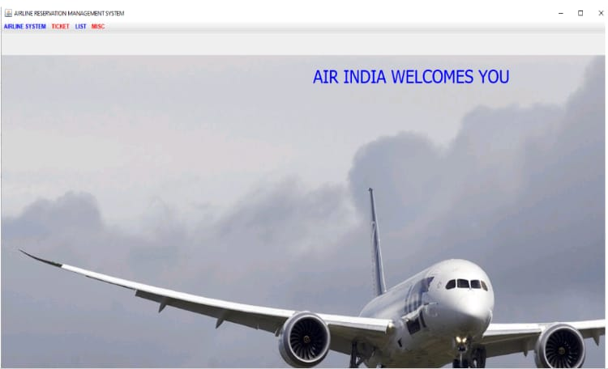

## 4.2 LOGIN PAGE:

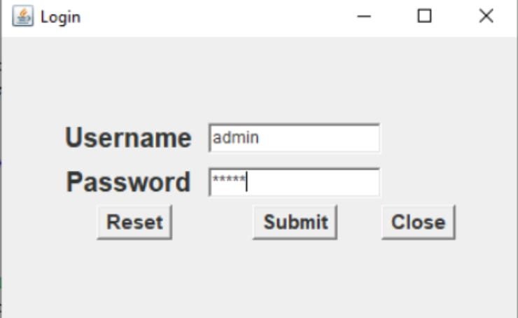

## 4.3 CUSTOMER DETAILS:

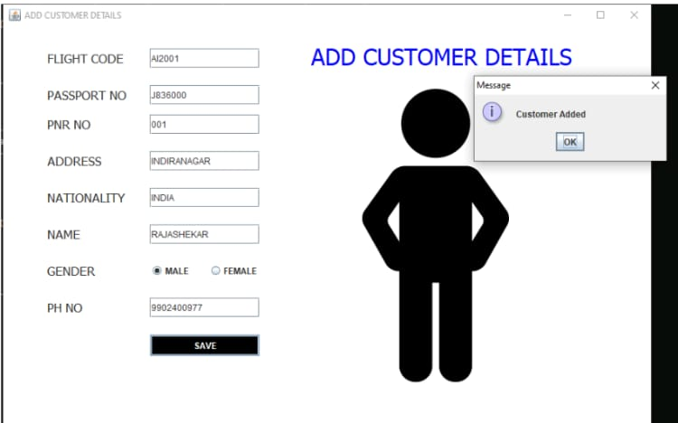

## 4.4 PAYEMENT PAGE

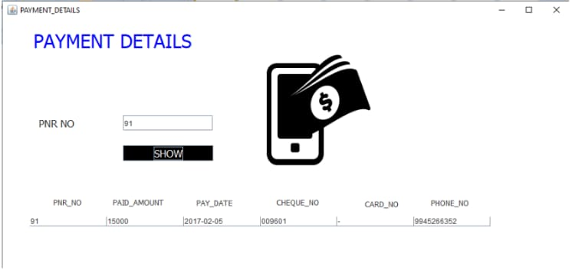

## 4.5 CANCELLATION

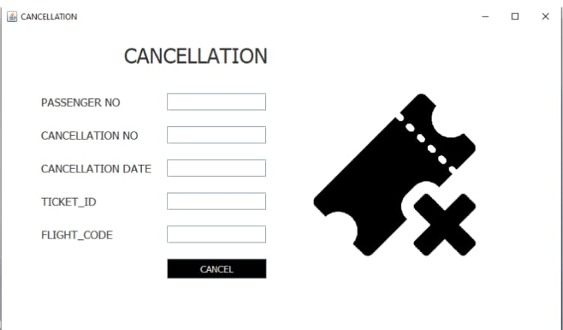

# CONCLUSION

With the help of our project, PG students will be able to effortlessly choose their preferred research topics, submit their project and view the results of the assessment on the website. The website will organize all their important data and make them accessible at their private accounts, saving them huge amounts of time.

**REFERENCES**

1. [**https://www.javatpoint.com/java-tutorial**](https://www.javatpoint.com/java-tutorial)

1. <https://www.wikipedia.org/>

1. <https://www.w3schools.com/sql/>

1. [SQL | Codecademy](https://www.codecademy.com/resources/docs/sql)